# AI ASSISTED CODING

# LAB TEST-1

NAME-S. VRINDHA REDDY

HALL NUMBER:2403A51255

BATCH:11

QUESTION-1: write a python code to calculate the sum of odd and even numbers in a given list. Using zero shot prompt

PROMPT: Write a Python program to calculate the sum of odd and even numbers in a given list using with zero short prompt.

CODE:

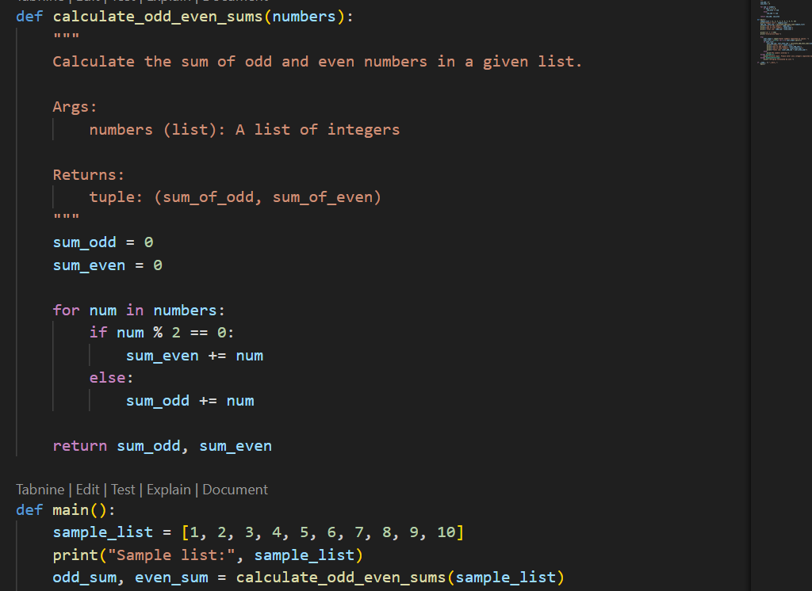

OUTPUT:

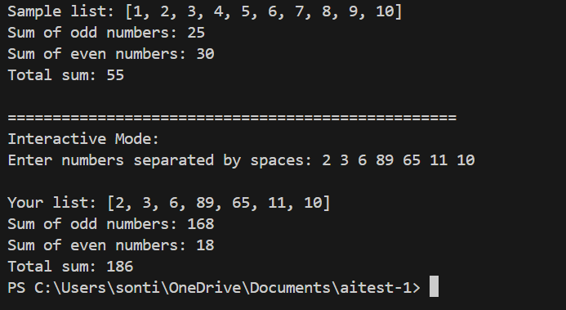

QUESTION-2: write a python code for a given list of integers, remove duplicates and print the sorted result. Use one shot prompting.

PROMPT: write a Python program that removes duplicates from a list of integers and prints the sorted result using with one shot prompt.

CODE:

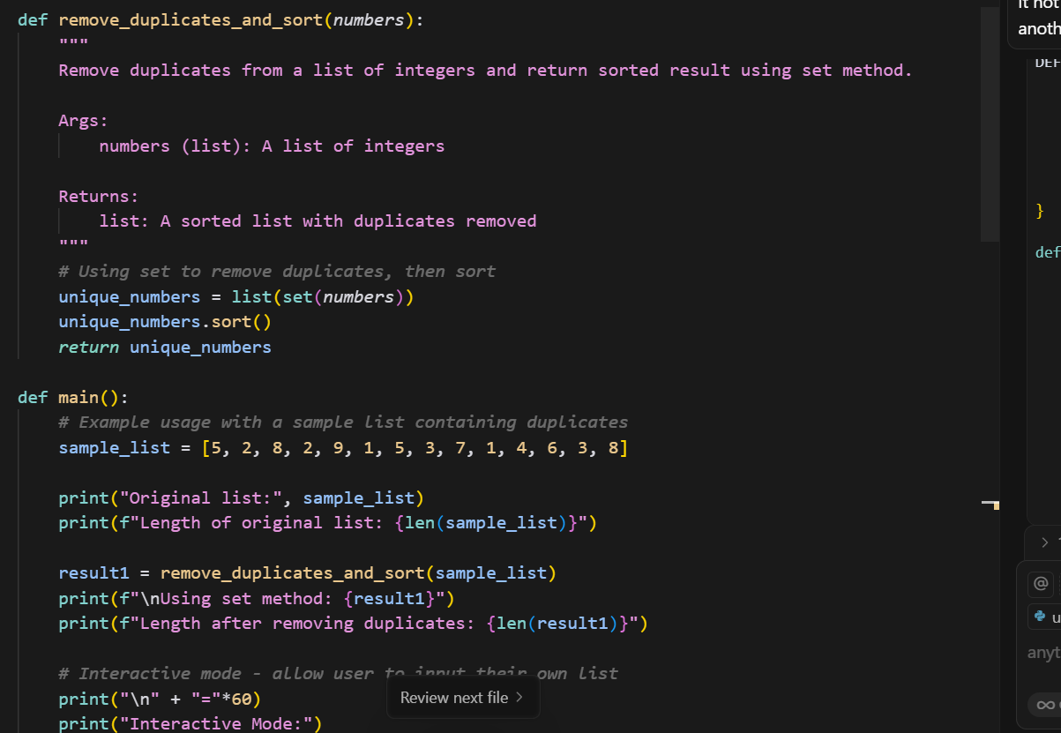

OUTPUT:

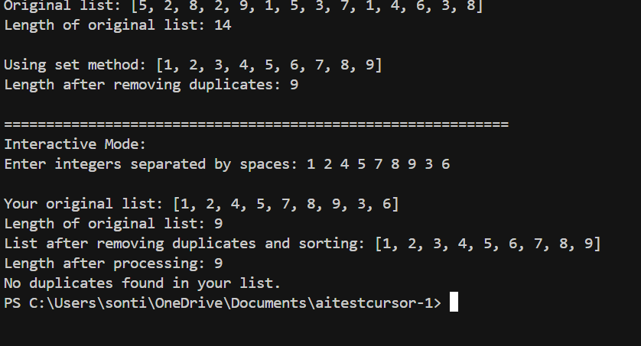

QUESTION-3: Write a Python function that converts the temperature between Celsius, Fahrenheit, and Kelvin based on use the cursor AI tool. Use few short prompting

PROMPT: write a Python function that converts temperature between Celsius, Fahrenheit, and Kelvin based on user choice using with few short prompts.

CODE:

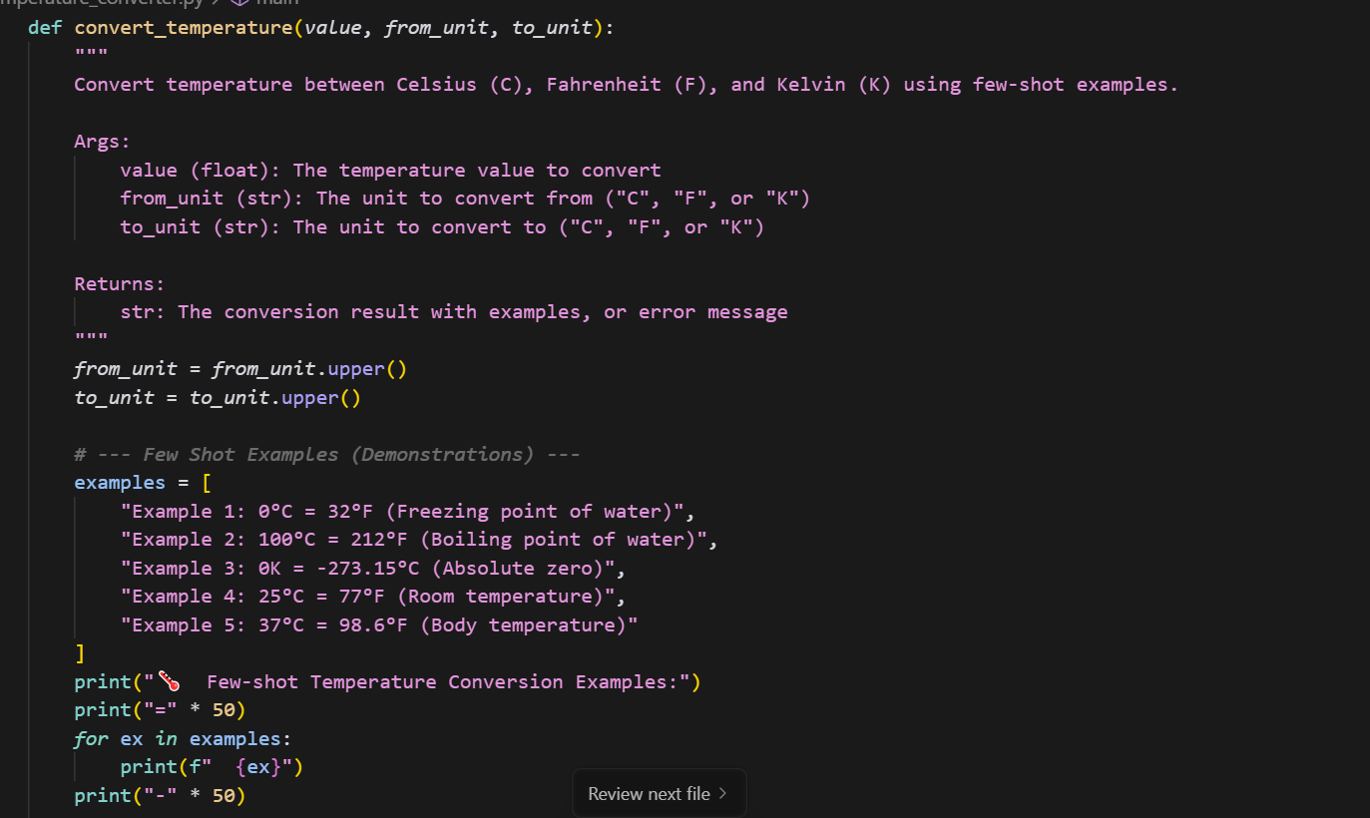

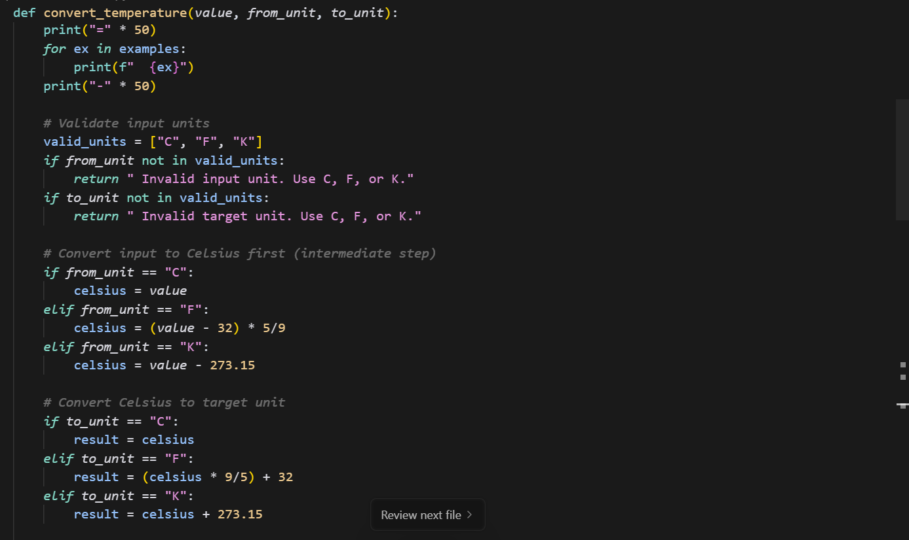

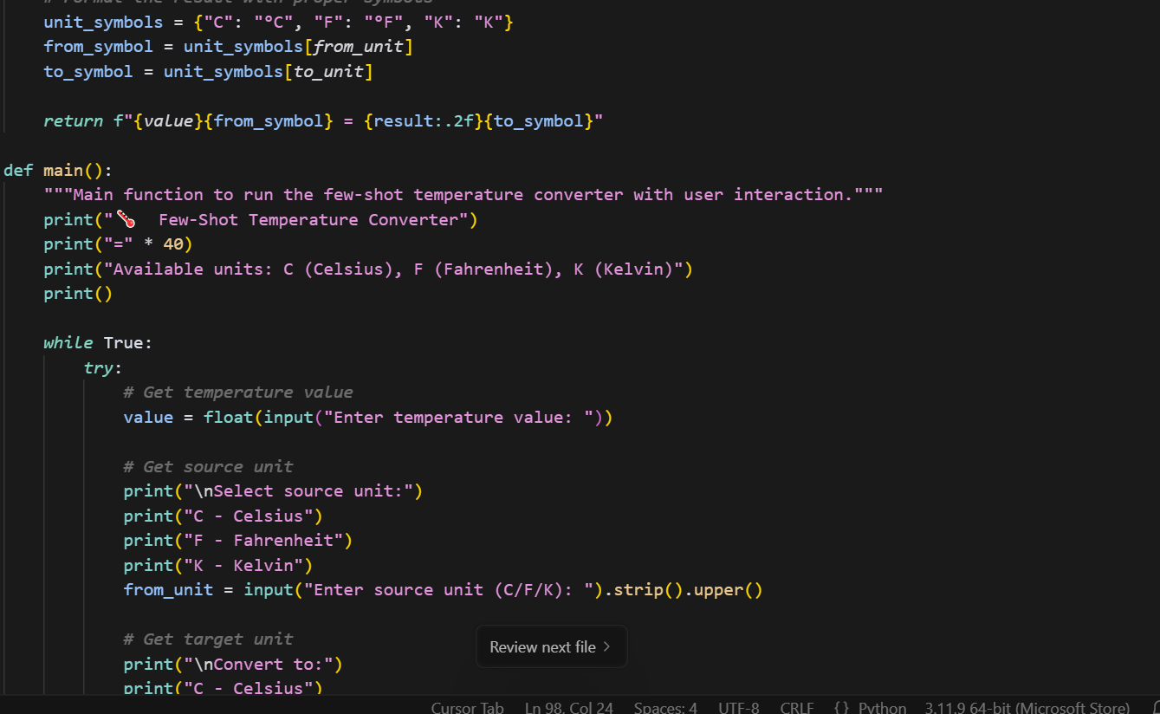

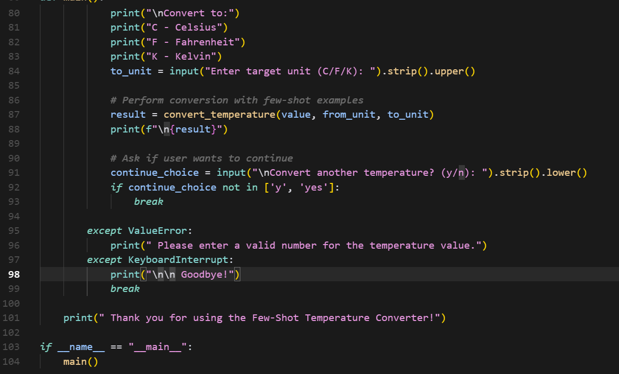

OUTPUT:

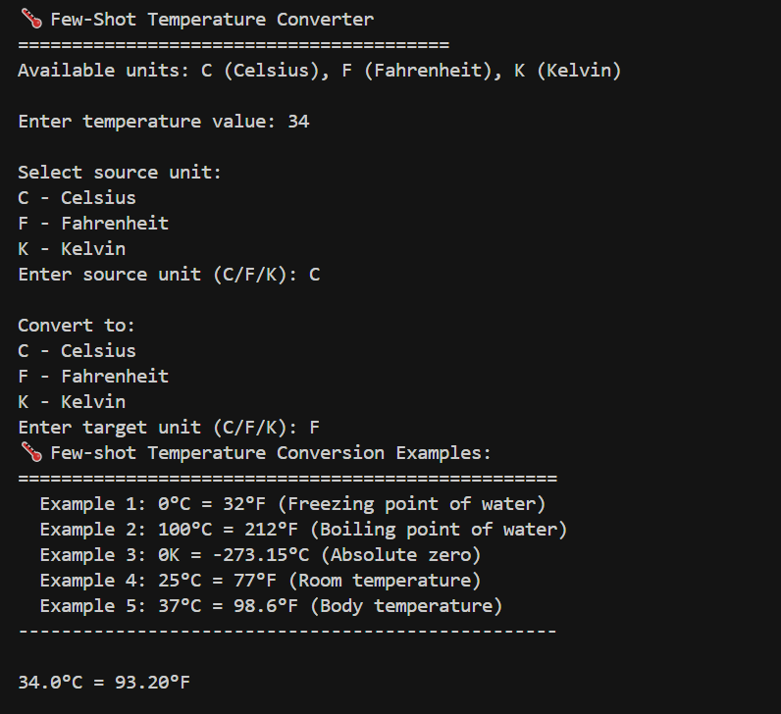

QUESTION-4: Write a Python function to remove punctuation, convert to lowercase, and remove stop words from a given text. Use the Cursor AI tool. Use zero shot prompting.

PROMPT: Write a Python function to remove punctuation, convert text to lowercase, and remove stop words from a given text with using zero shot prompt.

CODE:

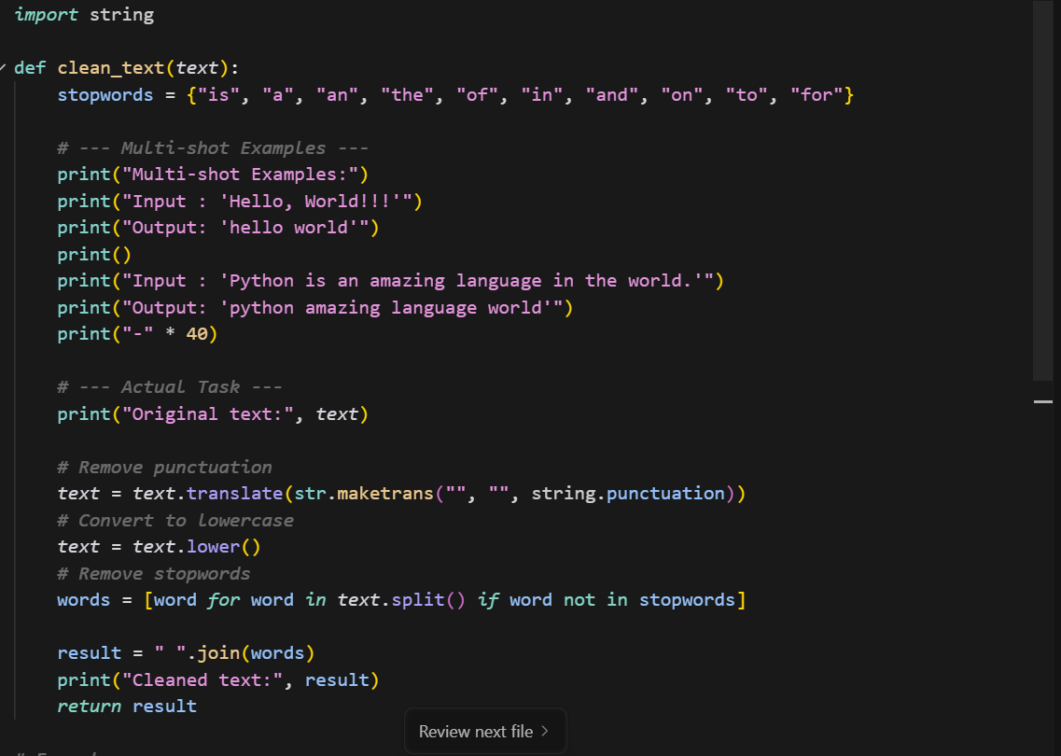

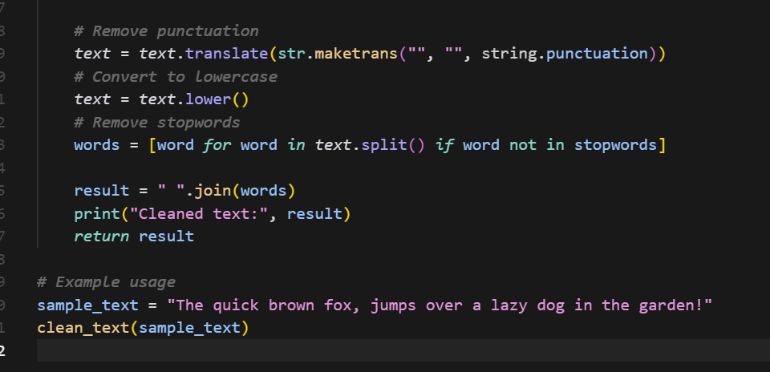

OUTPUT:

